## Merchant Name: Paramify Implementation POC: Royce *(IM to fill)* CX POC: *[IMP to Add]*

### 

### 

| Notes Sections   *(AE to fill if they have, Implementation to be completion DRI on handoff)*   * Info on how merchant bills  **💸 Paramify’s Current Billing Process**  * **Manual & HubSpot-Driven:**    + Sales closes deals in HubSpot using quotes signed via DocuSign.   + Once a deal is signed, Seth manually pulls the quote data and creates invoices. * **Invoices in QuickBooks:**    + All invoices are manually entered into QuickBooks by Seth based on signed quotes.   + No automated sync from HubSpot → QuickBooks. * **Revenue Tracking:**    + ARR is tracked in a **Google Sheet waterfall**.   + Ignite Spot uses a lightweight tool (outside of QuickBooks) to handle basic rev rec. * **Collections:**    + Customers pay in a variety of ways: QuickBooks payment links, direct ACH, checks, or through AP portals like Coupa, Cisco, Graphite, and Bill.com.   + Each of these methods often requires different invoice formatting or submission processes (e.g. special file formatting or excluding hyphens from invoice numbers). * **PO-Based & Partner Billing:**    + Many customers issue POs, which must be manually tied to invoices.   + They’re moving into a **partner-led model** where they’ll bill a single partner for 100+ downstream clients, dramatically increasing complexity. * **Product / Pricing Structure:**    + Historically used many line items on contracts, which made billing complicated.   + Transitioning to a simpler 3-tier SaaS product model + add-ons (e.g., for ATO support), but still anticipates complex contract-based custom pricing.   1) What is the merchant temperament?  Seth is effectively a team of one, handling all of Paramify’s billing, invoicing, and reporting. He cares most about eliminating manual work, keeping costs low (especially upfront cash out), and setting up systems that scale without adding headcount. He’s direct, transparent, and pragmatic. Communicates with clear priorities, moves fast, and appreciates straightforward, low-friction solutions.  3) What are the Tabs features that the key POC cares about?  **Renewals & ARR dashboards:** To replace CS + finance spreadsheets and give a clear view of upcoming renewals, notice periods, and expansion/contraction by customer.  **Invoice automation + QuickBooks sync:** So Seth never has to manually create invoices again or chase sales for billing info.  **Collections with bank feed matching:** Auto-matching payments via Plaid to cut down on reconciliation work.  **Exportable, investor-friendly reporting:** Customer-level ARR + churn/expansion detail he can easily pull for investors.  **Support for POs & AP portal billing:** Including auto-captured PO fields and formatted invoices for Coupa, Cisco, etc.  **Unlimited users & CS visibility:** So his CS team can track renewals and collections directly without needing more spreadsheets or HubSpot hacks. |
| --- |

### Billing model *(Entire Section: Implementation to fill section)*

* Are there unique things about the customer creation process for this merchant?
* Information on how merchant bills
* How contract is broken up
* One off things to know about the merchant

### Contract Processing Steps *(Entire Section: Implementation/Success to fill Post-Go Live)*

* **General:**
  + Most contracts are standard order forms with BTs listed in the “Annual Subscription Fees” table
* **Service Start Date:** last signature date if available; if not, use the “Quote Expires:” date at the top left
* **Billing Start Date:** same as Service Start Date
* **Months of Service:** use the length of the contract; will typically be 1-3 years
* **Frequency:**
  + Default to Annual for items priced as annual subscriptions
  + However, override if the “Invoicing & Payment” or “Comments” section specifies installment cadence
    - [Example](https://garage.tabsplatform.com/prod/contracts/b305f151-0990-4be7-a456-5a25bc8e7be1/terms/revenue) (check accuracy)
      * “Client shall receive an invoice for 25% of the Total Fees following the execution of this Order Form, and will receive additional invoices for 25% of the Total Fees every quarter for the next 4 quarters until annual amount is paid.”
    - 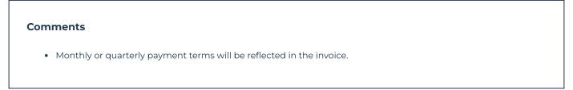
* **Net Terms:** use the “Invoicing & Payment” section
* **Quantity:** use the quantity column
* **Integration Items:**
  + Use [this mapping](https://docs.google.com/spreadsheets/d/1VlvaPLi_Zc5fGOfzd3TsXi2x9fCjftejnn-GKsgAA7U/edit?usp=sharing) exactly
* **Price**
  + Use price column with the appropriate calculation if invoicing cadence is specified
    - Most prices are listed as annual totals - if quarterly billing, would need to divide by 4
  + Create separate negative BTs for discounts
    - If discount is applied to a specific product, you can use in-line discounting
  + Process $0 BTs
* **PO# on Invoice Field**
  + After marking the contract as processed, check if there is a PO# on the contract.
    - If so, add the PO# to all invoices that the contract generate
  + 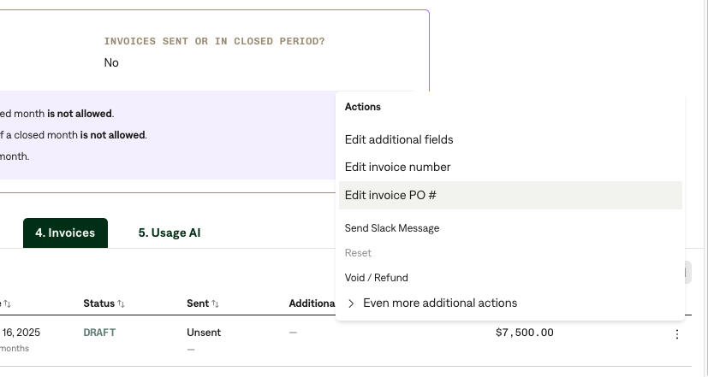
* **Customer Creation for Partnership Deals**
  + For Partnership Deals -> when a contract has (Client) next to the customer name in the header (screenshot below)
    - The company in parentheses is the partner. In the below example, the partner is Coalfire
  + When you create a customer, the billing email for the customer should be the Partner’s billing email
  + 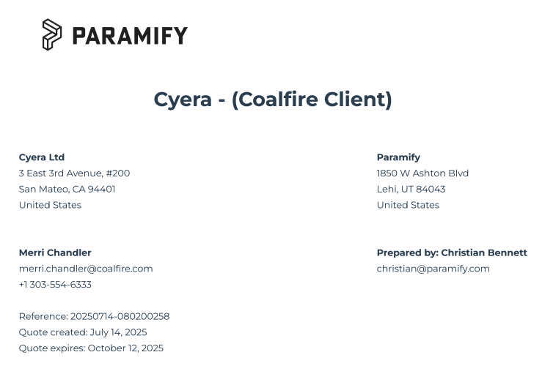
    - In this example, the billing email should be the Coalfire email
  + However, the customer name *should still be* Cyera.
* AWS Marketplace Contract Customer Creation
  + 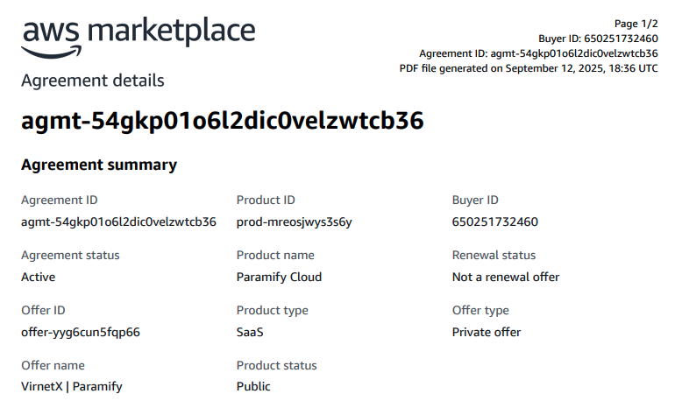
    - In the example above, the customer should be “VirnetX” ***not “***AWS Marketplace”

1. Anything to ignore in contracts?
2. Specifics processing things the merchant has requested that may differ by contract (e.g. always back-date invoice date to final day of the month)
3. Default Service Term
   1. If None Listed, Ops Default is 1 Year
4. Default Net Payment Terms
   1. If None, Ops Default is 0
5. Default Billing Frequency
   1. If None Listed, Ops Default is Monthly
6. How do we handle taxes as a line item?
   1. If None Listed, Ops Default is every tax line item becomes a BT

### Events Processing (if necessary) *(Entire Section: Implementation/Success to fill Post-Go Live)*

* Any important information on events billing

Integration Items Processing (if necessary)  
*(Entire Section: Implementation/Success to fill Post-Go Live)*

* What are the instructions for assigning integration items?
* Example: All Statsig integrations items should be labeled as “Sales”
* Example: All “Pinata” integration items should be labeled as “Software Subscription Bundle” unless otherwise noted by Merchant

Post Processing Communications (if necessary)  
*(Entire Section: Implementation/Success to fill Post-Go Live)*

* Does the Ops Team need to notify anyone on the team re: completion of processing batches in Implementation or Active phase?
* Who needs to be notified and when?
  + Example:
    - Who: Customer Success [Azmat Aziz] needs to be notified
    - Where: Messari internal merchant channel
    - When: contracts are processed [Merchant Phase: Active]

### Customer Information *(Entire Section: Implementation/Success to fill Post-Go Live)*

* Any important information on specifics customers of this merchant
  + Special memo’s certain invoices require
  + Invoice changes due to merchant/customer relationship

### Feature Requests *(AE to fill for all requests prior to Imp handoff, Imp to fill prior to go-live/Success to fill to fill Post-Go Live)*

* FR 1
  + What is it
  + Why it's important
  + Urgency

### Merchant Calls *(AE to fill for all videos prior to Imp involvement, Imp to fill prior to go-live/Success to fill to fill Post-Go Live)*

* <https://us-56595.app.gong.io/call?id=5696792684594689>
* <https://us-56595.app.gong.io/call?id=5926197220134055884>
* <https://us-56595.app.gong.io/call?id=3819655738428647144>